**Testing function**

Testing function is a function presence on **find**, **findIndex**,…. Array methods, where it’s used to scan elements of array from **left to right** and return element that achieve the condition

**Syntax:** **Arrayname.find(parameter => condition) where** parameter can be any character.

**Example:**

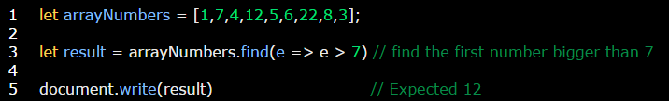

**Example:**

